Detection of Pipe Corrosion using Image Processing and Machine Learning

Pavan S¹, Nikhil², Pavan Kumar S³, Nikhil Kulkarni⁴, Dr Gunavathi H S⁵

¹ ² ³ ⁴ Students in the Department of Computer Science and Engineering,
Bangalore Institute of Technology, Bengaluru
⁵ Assistant Professor in the Department of Computer Science and Engineering,
Bangalore Institute of Technology, Bengaluru

Abstract: Pipeline is one of the most commonly used safe and efficient hydrocarbon modes of transport. The consistency of these pipes is critical to ensuring plant health, human, and environmental protection with the handling of large quantities of plant fuels (hazardous, flammable, toxic). Corrosion decreases the integrity of the pipes and likely decreases pipe life, whether external or internal surface. Therefore, an important function is timely identification of corrosion. The traditional manual inspection system conducted by human inspectors requires a great deal of time and energy and a lot of effort. Therefore, this research suggests a digital approach based on images to automate the corrosion detection process. The pipe surface characteristics shall be extracted using image texture including the statistical properties of color channels, Gray-Level Co-Occurrence Matrix and Gray-Level Run Length. The support vector machine is then used to create a hyper-plane that classifies it as corroding or not. The proposed model can thus be effective during the survey phase of all types of pipes.
Keywords: Statistical properties, GLCM, GLRL, SVM, CBC, CNN, FLDA.

- Introduction

Metallic corrosion is a natural process that transforms a more chemically stable type of polished metal, such as hydroxide or oxide. Metals reacting with their environment cause corruption. Corrosion is consuming trillions of dollars a year in infrastructure and in the industry around the world. There is also no need to overestimate the importance of corrosion testing.

Corrosion is a chemical process that has been caused by very few electrochemical reactions. There are a number of ways of corrosion, including the general corrosion, which are widely distributed non-protective rust flocks and which are a localized corrosive point of attack. These pipes are susceptible to external corrosion, flaws, corrosion, and a number of similar types. Cracking that is sometimes recognized as stress corrosion cracking can also cause corrosion.

In order to preserve the integrity of the corrosion detection pipes, a timely process should therefore, be established and cost-efficient processes developed. Although a wide range of current approaches to corrosion detection pipe inspection is available. Few approaches are Ultrasonic testing, magnetic flux leakage, and a direct evaluation. These approaches all have that which include high equipment costs, restricted scope of inspection, and unable to identify tiny corroded areas. There is an immediate need for an efficient and low-cost solution for daily evaluation of the pipe systems due to the huge numbers of tubing systems to be examined and minimally accessed in developing countries to sophisticated, cost-effective machinery.

2. Literature Review
The earlier approaches for Detecting corrosion of pipe involved Deep transmission learning is applied to automate CBC (coating breakdown and corrosion) assessment using CBC inspection software, corrosive damage assessment by KBS [1]. An integrated CBC evaluation framework is developed, [2] Is an advanced approach that aids the engineer in his task of determining the amount of harm done to metal skin and thus offers computation of the corrosive casualty. Metaheuristic Optimized Edge Detection [3] Method for image processing automatically detecting cracks on concrete wall surfaces using the Prewitt, Canny, Sobel and Roberts algorithms was developed. CNN (Convolution Neural Network) for corrosion detection. [4] A CNN determines the applicable classification features that were hand engineered in conventional algorithms. Real time Metal inspection [5] includes large surface defects and metal structure dimensional defects, and the consistency of metal products is guaranteed by these defects. Recognition of Digital Image [6] Using conventional K-means in H part, DCDR color space in RGB and HSI color space in DCDR. Evaluation of texture and color features [7], use of FLDA (Fisher’s Liner Discriminant Analysis) to analyze the ability of the corrosion descriptors.
3. Methodology
The steps followed in the proposed system to identify corrosion are as shown in the figure given below.
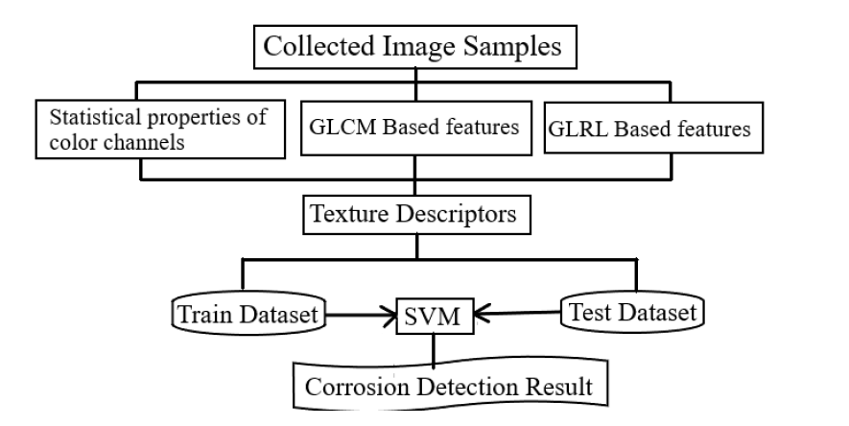
Figure 1. Block diagram

3.1 Image Analysis of the Textures
The detection of corroded areas on the basis of the complex and misleading surface properties of the pipe that contain several irregular objects, such as the ground and paints, make it a tough task to use two-dimensional image samples. The use of data from a single pixel is also clearly unsuitable for the detection of corrosion. This is the reason both non-corrosion and corrosion categories may include a pixel with the same color values. Texture information from a specific area of the pipe’s surface may, therefore used to define the fault of interest. The textures describing surface characteristics of the tube are explained in this paper.
3.2 Statistical properties of color channel
This paper reflects the statistical characteristics of the three channel colors of a sample of pictures (red, green and blue). This is why an image in a RGB format is defined. In addition to RGB, other color spaces such as HSV can help detect corrosion. However, in this study, we are based on the original digital camera RGB color model. In this paper, we extract six features in three different colors (Red, Green, and Blue). The six statistical properties extracted from the images are Mean, Standard Deviation, Skewness, Kurtosis, Entropy, and Range. All these six properties are extracted at three different color channels, thereby extracting (3*6)18 features.
3.3 Gray-Level Co-Occurrence Matrix (GLCM)
This is a widely used procedure for studying an image. The first step is to convert a color image to a grayscale image. Let δ = (r, θ) be a variable quantity represented in the coordinate. In this paper, we will be extracting 4 features at 4 different angles. The 4 features extracted are Angular Second Moment, Contrast, Correlation and entropy, each of these features are extracted from the image for different angles namely {0°, 45°, 90°, 135°}. Therefore, a total of 4*4=16 features are extracted from the image.
3.4 Gray-Level Run Length (GLRL)
This procedure is proposed by Galloway for texture classification. This approach is very effective for differentiating textures of various fineness and was successfully applied in different fields of research. A run-length p (i*j) matrix is calculated in a certain direction. This can be used to measure short-term stress (SRE), long-term concentration (LRE), Gray-level non-homogeneity (GLN), run-time non-homogeneity (RLN), and run-percentage (RP). Chu also proposed the low-gray running emphasis (LGRE) markers and high-gray running accent (HGRE). Dasarathy and Holder suggested that low gray short-term accent (SRLGE), high-gray short-term emphasis (SRHGE), low-gray long-term emphasis (LRLGE) and long-gray high-gray long-term focus (LRHGE) be calculated. Table 1 summarizes the above measures. Consequently, 11 features for 4 different angles {0 °, 45 °, 90 °, 135 °} which gives a total of 44 features are obtained as given in the below table.

Table 1. Texture descriptors using GLRL
DESCIPTOR | NOTATION
Short run emphasis | SRE
Long run emphasis | LRE
Gray-level nonuniformity | GLN
Run length nonuniformity | RLN
Run percentage | RP
Low gray-level run emphasis | LGRE
High gray-level run emphasis | HGRE
Short run low gray-level emphasis | SRLGE
Short run high gray-level emphasis | SRHGE
Long run low gray-level emphasis | LRLGE
Long run high gray-level emphasis | LRHGE

3.5 Support Vector Machine (SVM)
SVM is a robust method for recognition of patterns for statistical education theory. Since the input function is classified in to two categories: −1 (non-corrosion) and +1 (corrosion), an SVM model is responsible for constructing a decision-making spatial area by using a hyperplane it divides the input into two different regions. The goal of the SVM algorithm is to define a decision boundary in order to achieve the greatest possible distance between groups. SVM also uses the kernel to turn a nonlinear classification function into a linear classification function. First, an SVM model maps input data to a hyperplane which can separate the data from the original room. After extracting all the 78 features using the image processing technique, we train our SVM model with the 78 features. As explained above SVM model will map the input data and using hyperplane creates two different regions (corrosive and non-corrosive). The model will try to identify a pattern from the above features extracted and will use it for testing.
4. Result
The developed model was successfully tested using the test image datasets. A total of 2000 image samples are used for training and testing the SVM model as data sets. The training and test dataset are divided into 80% and 20% of the total image dataset respectively. The test results show the accuracy rate (CAR) of the classification (95.75%).
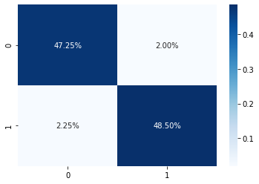
Figure 2. Confusion matrix for the classification model
5. Conclusion
In each pipeline system, corrosion is commonly observed as a defect. In order to maintain the integrity of pipe systems, the timely recognition of corrosion is important. A self-recognizing method based on image processing and machine learning is proposed in this paper. Imaging methods such as statistical properties of the colored image by three texture descriptors, gray-level co-occurrence (GLCM) matrixes, grey-level running lengths (GLRL) are used to extract features. The machine learning method that is a support vector machine (SVM) classifies the image into two classes-corrosion and non-corrosion. The newly developed program can also be useful as a way to rapidly evaluate pipeline systems for industries such as the coal, oil and chemical and petrochemical industries.

References

- Lili Liu, Estee Tan, Yongda Zhen, Xi Jiang Yin, ZhiQiangCai, “AI-facilitated Coating Corrosion Assessment System for Productivity Enhancement”, 2018 13th IEEE Conference on Industrial Electronics and Applications (ICIEA).
- Nabil Cherit, NacerEddineBacha, Abdelhak Skender, “Knowledge base system (KBS) applied on corrosion damage assessment on metallic structure pipes” Heliyon 4 (2018) e00865.
- Nhat-Duc Hoang, Quoc-Lam Nguyen, “Metaheuristic Optimized Edge Detection for Recognition of Concrete Wall Cracks: A Comparative Study on the Performances of Roberts, Prewitt, Canny, and Sobel Algorithms”, Hindawi Volume (2018).
- ” Deegan J Atha and Mohammad R Jahanshahi , “Evaluation of deep learning approaches based on convolutional neural networks for corrosion detection Structural Health Monitoring(2017) 1–19.
- Dhanshree M. Lohade, Prof. P. B. Chopade ,“Realtime Metal inspection for surface and dimensional defect detection using image processing techniques” 3rd International Conference on Electrical, Electronics, Engineering Trends, Communication, Optimization and Sciences (EEECOS)-(2016)
- Kuo-Wei Liao, Yi-Ting Lee , “Detection of rust defects on steel bridge coatings via digital image recognition”, Department of Civil & Construction Engineering, National Taiwan University of Science & Technology, No.43, Sec. 4, Keelung Rd., Taipei 106, (2018) Taiwan.
- Fatima N.S. Mederios, Geraldo L.B. Ramalho, Mariana P.Bento, Luiz C.L. Mederios, , “On the evaluation of texture and colour features for non-destructive corrosion detection” Hindawi Publishing Corporation (2018)

